**CMPS 350 Project Phase 2 – Report**

**Education Platform**

**(10% of the course grade)**

**The report must be submitted in Word format only**

|  |  |
| --- | --- |
| **Group Members** | Karim Elnaggar (202307871)  I did the project by myself so as you told me I only did the statistics use-case  **Emails:** ke2307871@student.qu.edu.qa; |
| **GitHub link** | https://github.com/kareem-ke2307871/project |

**Grades :**

**The student fills only the “Implementation Percentage”: Please specify either: *Working (completed x%)*, *Not Working (completed x%)* or *Not done*.**

|  |  |  |  |  |
| --- | --- | --- | --- | --- |
| **Criteria** | **%** | **Functionality**\* | **Quality of the implementation** | **Grade** |
| Design and implement the Data Model. | 10 |  |  |  |
| Init DB: populate the database with the data from the json files in seed.js | 5 |  |  |  |
| Server actions, APIs and Repository Implementation to read/write data from the database | 25 |  |  |  |
| Statistics use-case with NextJS | 40 | 100% |  |  |
| **Documentation**  - Data Model diagram.  - UI Design with screenshots and description.  - Database queries.  - Conducted tests and evidence.  - **Contribution** of each team member [-10pts if not done] | 20 | 100% |  |  |
| **Total** | 100 |  |  |  |
| Copying and/or plagiarism or not being able to explain or answer questions about the implementation. | -100 |  |  |  |

**Important remark: In case of copying and/or plagiarism or not being able to explain or answer questions about the implementation, you lose the whole grade.**

**\* Criteria for grading the functionality:**

- The functionality is working: you get 70% of the assigned grade.

- The functionality is not working: you lose 40% of assigned grade.

- The functionality is not implemented: you get 0.

- The remaining grade in all cases from above **is assigned to the quality of the implementation**,

- The grades are distributed on the various use cases, when the design/implementation is partial, you get only the grades of designed/implemented use cases.

Code quality criteria, include:

- Use of meaningful identifiers for variables and functions (e.g. using JavaScript naming conventions)

- Pages are responsive

- Clean code: simple and concise code, no redundancy

- Clean implementation without unnecessary files/code

- Use of comments where necessary

- Proper code formatting and indentation.

**You lose marks** for code duplication, poor/inefficient coding practices, poor naming of identifiers, unclean/untidy submission, and unnecessary complex/poor user interface design.

**Important Remark**:

**[Grades: 100-85]:** Will be given only to **fully functional application** with **all the quality criteria cited above met** and the project has excellent **design for the various functionalities**. **The report is professional**.

**[Grades: 85-80]:** Will be given only **to functional application** **with most of all the quality criteria cited above met** and the project has good design for the various functionalities. **The report is professional**.

**[Grades: 80-75]:** 80% of the application functionalities are functional. The project respects partially the quality criteria. **The report is professional** but misses some information.

The grades are not negotiable. We expect that only a small portion (around 15%) of the class will be able to meet the criteria for the grades **[100-85]. You should work hard to and demonstrate the merits of your application to earn those grades.+**

# Description of your proposed platform

1. Courses platform, where students can log in to search for courses they want or view their learning path,
2. Also instructors can log in to search for the courses they teach and the student they have in these courses to alter and submit their grades.
3. You can also check for statistics for all courses and students

# Data Model

Give entity diagram, Prisma schema,

# Web API, Server Actions and repository

List all your implemented methods (functions) to query your data,

Show how you organized them in WebAPI and Server actions

# Implemented statistics use case

# User Interface

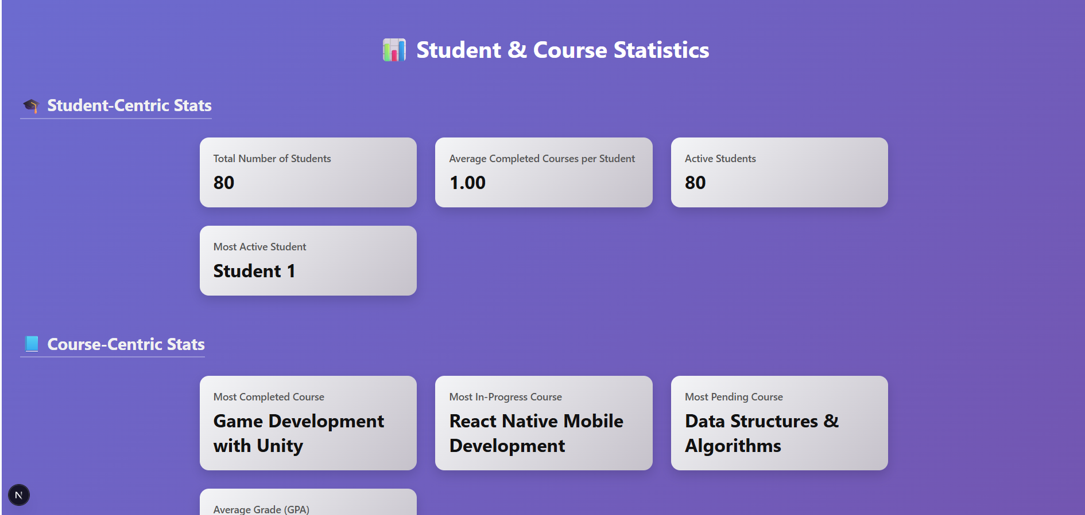

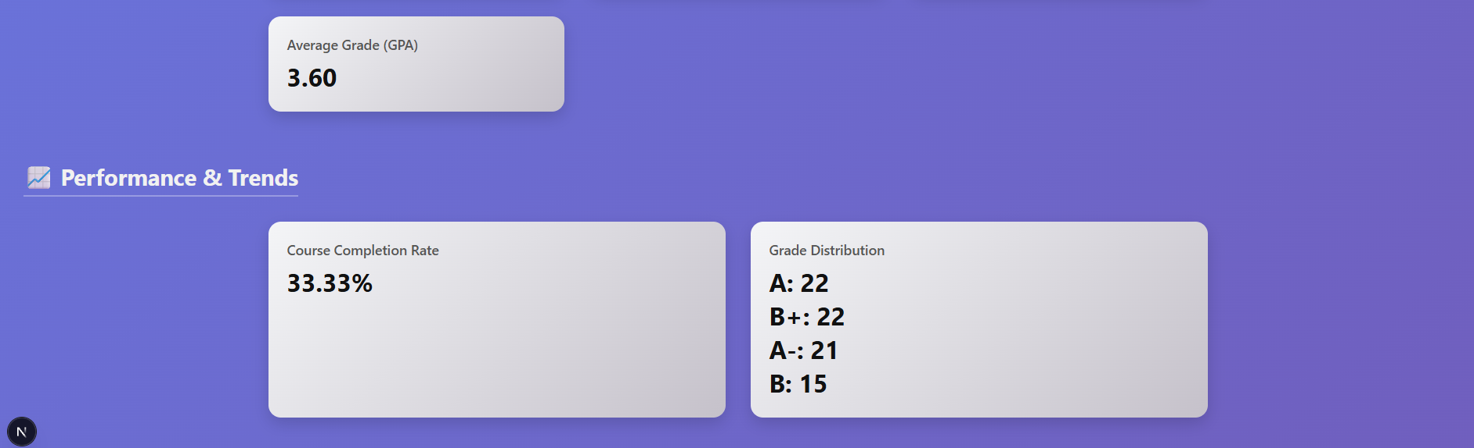

# Implemented queries

# Data used in the statics

Number of students, their grades in the courses, their pending, completed and in progress courses

# Conducted tests

# Implemented queries

Doctor I know it looks like I did nothing in phase two but you just told me to do statistics, that implies no data transfer, no API points, and no action server along with the REPO (which were in part 1)

# Discussion of the project contribution of each team member

|  |  |
| --- | --- |
| **Student name** | **Student contributions** |
|  |  |
|  |  |
|  |  |
|  |  |
|  |  |